July 2016
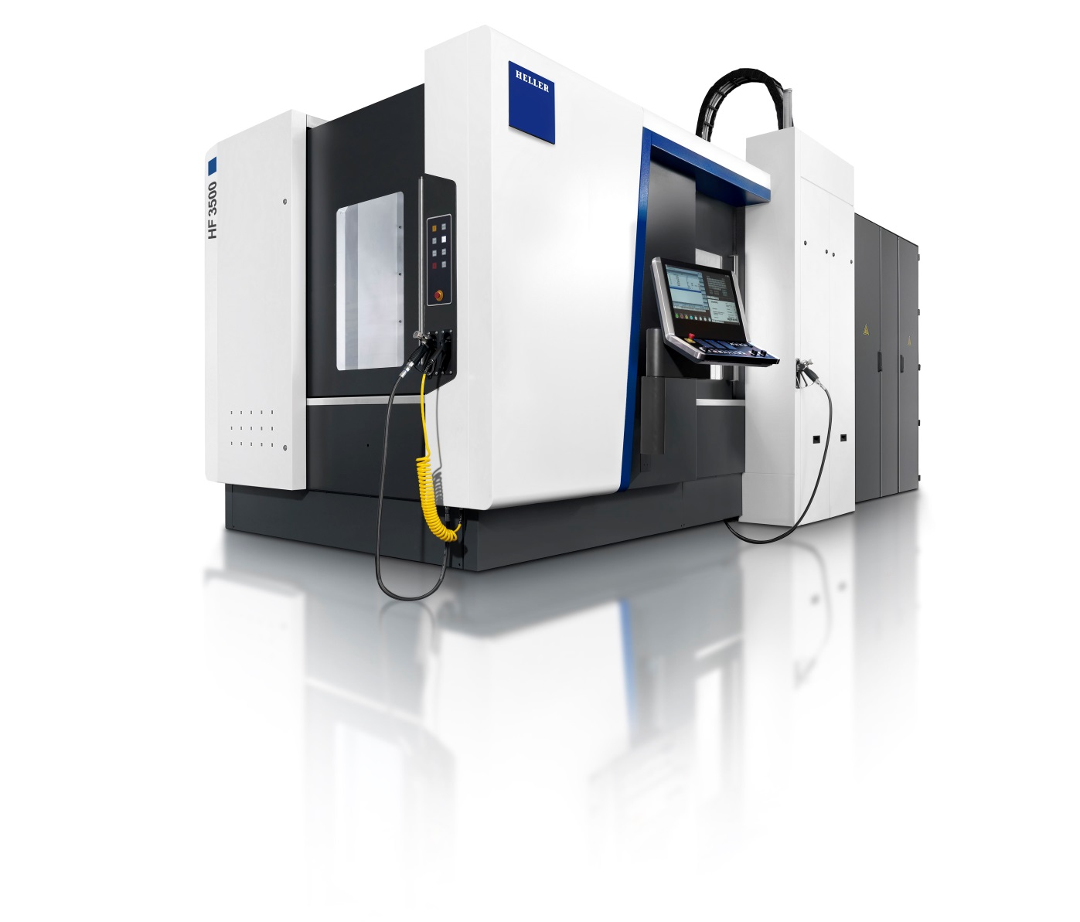
AMB 2016
The new HF series: productivity in 5 axes
Press relations
Gebr. Heller Maschinenfabrik GmbH

Marketing
Marcus Kurringer
Gebrüder-Heller-Straße 15
72622 Nürtingen
Germany
Phone: +49 7022 77-5683
Fax: +49 7022 77-165683
marcus.kurringer@heller.biz
The new HF series: productivity in 5 axes
For HELLER, the development of the new HF series is a logical step in completing the existing range of machines. The HF is a new machine series, enabling high productivity and universal application for medium and larger batch sizes. With the 5th axis provided by the workpiece, the 5-axis machining centres model HF 3500 and HF 5500 offer a significant reduction in idle times. The main target groups for this new machine concept are the automotive industry, its suppliers and the general machine building industry.
Highlights at a glance
The machining centres from the HF series feature a fifth axis provided by the workpiece and have been designed for dynamic 5-sided as well as simultaneous 5-axis machining. For this concept, HELLER has re-combined proven components also used in existing machine series to develop an extremely productive machine suited for a wide range of parts and materials. All rotational axes are provided by the workpiece. As a logical expansion of the existing product portfolio, the new machine concept is synonymous with high process stability, as proven principles used on existing machine series have been consistently further developed. The horizontal spindle, for example, enables fast tool changes, resulting in minimal idle times. High flexibility was another priority for HELLER in the development of the machine. Therefore the machining centre is either available in table design or equipped with pallet changer. Additionally, all machine series offer users the choice between the proven HSK63 and HSK100 motor spindles.
Robust and highly dynamic machine concept
As expected, the new series convinces with the known HELLER DNA. Quality, performance, high productivity, long-term reliability and stability in combination with excellent accessibility and ease of operation provide the basis for this. The basic structure of a machine provides the foundation for achieving high stability which is particularly important in 5-axis machining. The machines are characterised by the inherently rigid design of the bed and column construction, whilst the 5th axis is provided by the workpiece. They feature proven kinematics with three linear axes in X, Y and Z and two direct driven dynamic rotary axes in A and B. As usual at HELLER, the A axis is supported by a counter bearing. The counter bearing helps to achieve high dynamic rigidity even at high loads. Optionally, its powerful dynamics can be increased further with the “Speed-Dynamics Package”. According to HELLER, it provides 10 % shorter chip-to-chip times. Other strengths of the machine include milling with tilted axes (3 + 2) and high dynamics in 5-axis simultaneous milling. For reduced idle times, the HF series provides a high-speed NC tool changer based on lift-and-swivel principle.
Proven quality redefined
Compared to the H and F series, designed for heavy loads and large components or multiple clamping, HELLER's new HF series is tailored to dynamic 5-axis machining of medium to large batch sizes. Whilst model HF 3500, providing a maximum permissible workpiece weight of 550 kg, ranges between the H 2000 and H 4000, model HF 5500 enalbes a workpiece weight of 750 kg, positioning it between models H 4500, H 5000 and H 6000. Workpiece provisioning can optionally be effected using table loading or a pallet changer. The HF also provides a wide choice of spindles to suit different applications. Whilst the standard version is equipped with the powerful SpeedCutting motor spindle with HSK-A63, making it ideal for the machining of light metals, the (optional) PowerCutting spindle unit provides the necessary torque for high-performance cutting of cast iron and steel. Optionally, HELLER offers motor spindles with HSK-A100. The SC 100 spindle unit provides increased stability of tools and high speeds for universal application, whereas the PC 100 spindle unit offers high torque for use with large and heavy tools.
In terms of precision, HELLER relies on proven design. High positioning accuracy is achieved through direct drives in both rotary axes and direct, absolute measuring systems in all machining axes and automatic clamping. Whether used for cutting short- or long-chipping materials, everything about HELLER machining centres is well thought-out. To guarantee this, also in the future, the machines provide free chip fall during horizontal machining, a centrally arranged open chip conveyor and an INOX work area.
Operator touch panel
With the HF series, HELLER is presenting its new HELLER Operation Interface, the new operating panel with 24" screen technology, quick access technology in the control and XTENDS optional expansion applications to support the user. The optional work area camera, for example, optimally supports setting and monitoring functions during the CNC process.
Efficient and future-proof
For decades, HELLER has been synonymous with efficient production processes and high machining quality. This also applies to the well-conceived connection to all current automation systems. Target groups will be particularly interested in flexible integration into existing production systems. The new machine series is also flexible and customer-oriented in terms of tooling. The new machining centres enable continued use of existing tools from other HELLER machines and the use of manual clamping fixtures. Adaptation of hydraulically operated clamping fixtures is possible.
With the HF, HELLER again sets new standards in quality and precision. Combined with the Siemens Sinumerik 840D sl control and the new HELLER Operation Interface, the new concept is a future-proof investment.
Presentation at the AMB in Stuttgart
At the AMB in Stuttgart we will present the HF 3500 as direct load concept for single part production as well with pallet changer for the serial production.
HELLER booth
Hall 5, stand 5B55
PTW booth
Hall 5, stand 5D32

HELLER AT A GLANCE
Founded in: 1894 in Nürtingen
2015 workforce: 2530
2015 order intake: EUR 561m
2015 turnover: EUR 556m
Chairman of the Board: Berndt Heller
Managing Directors of the HELLER Group: Klaus Winkler, CEO
Manfred Maier, COO
Fields of business: 4-axis and 5-axis machining centres
Mill/turning centres
Flexible manufacturing systems
Machines for crankshaft and camshaft machining
CBC systems
Services
Production locations: Germany (Nürtingen)
United Kingdom (Reddich)
USA (Troy/Michigan)
Brazil (Sorocaba)
China (Changzhou)
Sales/Service locations: EUROPE
Germany (Hattingen, Salem, Goslar, Saarbrücken, Nuremberg, Nürtingen)
Italy (Verona) France (Paris)
Poland (Posen) Spain (Barcelona)
Sweden (Värnamo)
Switzerland (Niederbüren)
Slovakia (Vráble)
Russia (Moscow)
NORTH/SOUTH AMERICA
Mexico (Querétaro) Brazil (Belo Horizonte, Gravataí, Joinville)
ASIA
China (Beijing, Chongqing, Shanghai)
India (Pune)
Thailand (Bangkok)
Singapore

